# Docx guidelines

## Styles

MS Word styles are your friend. There are a way for the platform to recognize whether you intend a body of text to be a heading or a paragraph. For a human, it may seem like an easy task in distinguishing a paragraph from a quotation or a chapter title from a section header, but that’s because a typical human have seen lots and lots of text and developed an intuition in this regard. For instructions run by a computer, this task is not so simple.

This is why you must use MS Word styles in order for the computer to transform your manuscript into a book.

In order to choose a style, first find the “Home” tab at the top of your MS Word window. Secondly, either select a style from visible in the “Styles” box or click the “⊽” button on the right, choose “Apply Styles” and enter the name of a style you need. The “*Figure 1. How to select a MS Word style.*” shows you how to do it. In the “*Table 1. MS Word styles that affect the structure of the end result.”* you can find the most important MS Word styles you can use.

Figure 1. How to select a MS Word style.



When you choose a MS Word style selected content will change its appearance in your .docx file. Do not worry about it. Computers do not care how your content looks in MS Word, whereas applying MS Word styles will enable them to correctly structure your work.

Table . MS Word styles that affect the structure of the end result.

|  |  |
| --- | --- |
| **MS Word Style** | **Part of a book** |
| *Heading 1* | Heading 1 (e.g. chapter heading) |
| *Heading 2* | Heading 2 (e.g. section heading) |
| *Heading 3* | Heading 3 (e.g. sub-section heading) |
| *Heading 4* | Heading 4 (e.g. heading for dividing sub-sections) |
| *Heading 5* | Heading 5 (e.g. heading for parts divided with Heading 4) |
| *Quote* | Quotes |

## Headers

Use the following MS Word styles for headings in your work (e.g. for chapter titles, section headings, subsection heading, etc.):

# Heading 1 title[1]

## Heading 2

### Heading 3

#### Heading 4

##### Heading 5

Note that there is no heading 6.

## Styling body of text

### Paragraphs

First paragraph of each section should be styled with the “First Paragraph” style.

Every other paragraph should be styled as the “Body Text”.

### Typography

Currently, we support the following font formatting:

*Italics.*

**Bolded text.**

Subscript (e.g. H2O).

Superscript (e.g. 11th of November).

Note that some of the common text formatting options, like underlining, ~~strikethrough~~ and highlighting are not supported and might not work.

## Emoticons

💻➡📖😉

## Quotes

In our platform, we use the “Quote” MS Word style to format a quotation:

Sometimes you have to put a lot of manual work to automate something.

- Unknown Author

## Lists

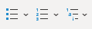

### Bullet lists

We support non-ordered bullet points…

* First point
* Second point
* Third point

### Ordered lists (numbering)

…as well as numbered lists.

1. First item.
2. Second item.
3. Third item.

### Multilevel lists

Multilevel lists are also supported.

1. Item 1
   1. Item 1.1
      1. Item 1.1.1
         1. Item 1.1.1.1
2. Item 2

### Other lists

You can also create nested unordered lists by indenting bullet points.

* point 1.
  + point 1.2.
    - point 1.3.
      * point 1.4.
* point 2.

## Multimedia

:::{caution}  
When you insert a multimedia file (image, video, etc.), MS Word might automatically insert the “Alt Text”. Please make sure that this Alt Text does not contain blank lines. To edit it, right-click on an inserted multimedia, select “View Alt Text…” and change the text that will appear on the right.  
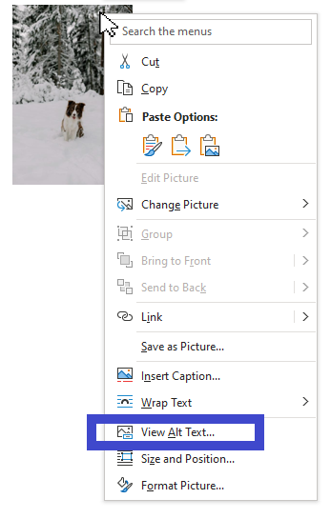   
:::

### Images

:::{card} TODO 🚧  
Feature to be added in TNB-62: “As an author I want to upload my assets to the asset management system”.  
First figure out infrastructure side of handling assets, then code the input side.  
:::

### Videos

:::{card} TODO 🚧  
Feature to be added in TNB-62: “As an author I want to upload my assets to the asset management system”.  
First figure out infrastructure side of handling assets, then code the input side.  
:::

### YouTube/Vimeo videos (mystmd feature)

If your video is hosted on one of supported platforms (at the time of writing of this document: on YouTube and on Vimeo) you can embed the video using the url. Use this syntax to add an embedded video (this is a syntax of a directive, which will be explained later).

:::{iframe} <https://www.youtube.com/embed/_TycjDn9WYE?si=HJAZlky46zWndbLE>  
:width: 50%  
:::

:::{iframe} <https://player.vimeo.com/video/266248400?h=79807d2eed&title=0&byline=0&portrait=0>  
:::

Note that the book will then be dependent on that external source - if deleted, the video will not be rendered.

Also, just copying the url to video might not work. You should create a special link. For example, on youtube.com you will have to click on the “Share” button, then select the “Embed” option and copy a url from a generated block of code.

Figure 2. How to get a link to embed a video from youtube.com.



## Tables

There are no explicit rules for formatting a table. As long as you will insert a proper MS Word table, the platform should be able to recognize it and its contents and render it.

|  |  |
| --- | --- |
| **Header 1** | Header 2 |
| Row 1, Column 1 | *Row 1, Column 2* |
| Row 2, Column 1 | Row 2, Column 2 |

Note that the styling of a table does not influence how the platform will render it. The general rules of styling are applied, though (see for example the bolded table headers).

|  |  |
| --- | --- |
| **Header 1** | Header 2 |
| Row 1, Column 1 | *Row 1, Column 2* |
| Row 2, Column 1 | Row 2, Column 2 |

## Directives

Directives are multi-line containers that allow you to place a complex element that will be interpreted by the platform. As a general rule, each directive consists of an opening colon fence (`:::`), name of a directive enclosed in braces (`{directive-name}`), content, and closing colon fence. Directives have to be continues text without blank lines. A syntax of a directive is presented below. Later in this chapter you will find examples of many different directives.

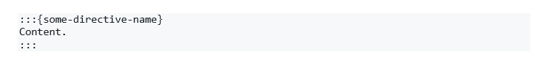

:::{important}  
Remember, directives must be a continues text undivided by blank lines. To avoid common problems with directives that span multiple lines, you might need to use the “Shift + Enter” instead of splitting lines with “Enter” to format your equation.  
:::

### Cards

You can group related information in a container box that will adjust to the width of the page.

:::{card} Card title  
Card content  
:::

### Admonitions

Admonitions highlight a particular block of text that exists slightly apart from the narrative of your page, such as a note or a warning.

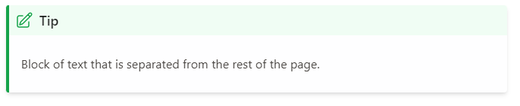

To achieve that, you have to use the following syntax:

:::{tip}  
Block of text that is separated from the rest of the page.  
:::

You can use different admonition types, which will be render using a color and an icon specific to that type. An icon might change in the future, but the general principle stays the same. Currently, the supported admonition types are as follows:

:::{attention}  
…  
:::

:::{caution}  
…  
:::

:::{warning}  
…  
:::

:::{danger}  
…  
:::

:::{error}  
…  
:::

:::{tip}  
…  
:::

:::{hint}  
…  
:::

:::{seealso}  
…  
:::

:::{important}  
…  
:::

:::{note}  
…  
:::

### Interactive elements

#### Dropdowns

:::{dropdown} Dropdown Title

Dropdown content

:::

#### Admonition Dropdowns

:::{note}  
:class: dropdown  
You can combine an admonition with a dropdown to create an interactive element in your book.  
:::

#### Tabs

::::{tab-set}  
:::{tab-item} Tab 1  
:sync: tab1  
Content of tab one  
:::  
:::{tab-item} Tab 2  
:sync: tab2  
Content of tab two  
:::  
::::

### Math

Unfortunately, we don’t support MS Word equations.

$$a^{2}+b^{2}=c^{2}$$

Instead, we do support a special `{math}` directive, which allows the platform to render equations written in LaTeX syntax.

:::{math}

e^{i\pi}+1 =0

:::

Constructing math equations in LaTeX syntax may seem daunting, but thankfully there are multiple tools to help you with that task. Look in your favorite web search engine (e.g. google) for “*online latex equation editor*” to find a few.

Another way of formulating an equation is by wrapping it between `$$` characters.

$$ Ax=b $$

This might be especially useful when constructing equations that span over multiple lines.

$$  
\label{maxwell}  
\begin{aligned}  
\nabla \times \vec{e}+\frac{\partial \vec{b}}{\partial t}&=0 \\  
\nabla \times \vec{h}-\vec{j}&=\vec{s}\_{e}  
\end{aligned}  
$$

### Code blocks (mystmd feature)

Currently we do not support interactive code blocks. But you can format a static code block to show a code snippet without executing it.

:::{code-cell} ipython3  
note = "Python syntax highlighting"  
print(note)  
:::

:::{card} TODO 🚧  
Feature to be added in future releases.  
:::

### Diagrams (mystmd feature)

:::{note}  
Note that the platform does not allow to use standard MS Word charts. It is advised to write chapters with charts, diagrams and other data visualization in separate Jupyter Notebook (.ipynb) files.  
:::

Mystmd supports mermaid diagrams. Please see [the documentation](https://mermaid.js.org/) on how to create graphs for your work. Few implementation examples are presented below.

#### Flowchart

:::{mermaid}  
flowchart LR  
 A[Hard edge] -->|Link text| B(Round edge)  
 B --> C{Decision}  
 C -->|One| D[Result one]  
 C -->|Two| E[Result two]  
:::

#### Sequence diagrams

:::{mermaid}  
sequenceDiagram  
 participant Alice  
 participant John  
 link Alice: Dashboard @ <https://dashboard.contoso.com/alice>  
 link Alice: Wiki @ <https://wiki.contoso.com/alice>  
 link John: Dashboard @ <https://dashboard.contoso.com/john>  
 link John: Wiki @ <https://wiki.contoso.com/john>  
 Alice->>John: Hello John, how are you?  
 John-->>Alice: Great!  
 Alice-)John: See you later!  
:::

#### Gantt diagram

:::{mermaid}  
gantt  
 title A Gantt Diagram  
 dateFormat YYYY-MM-DD  
 section Section  
 A task :a1, 2014-01-01, 30d  
 Another task :after a1, 20d  
 section Another  
 Task in Another :2014-01-12, 12d  
 another task :24d  
:::

#### Pie chart

:::{mermaid}  
pie showData  
 title Key elements in Product X  
 "Calcium" : 42.96  
 "Potassium" : 50.05  
 "Magnesium" : 10.01  
 "Iron" : 5  
:::

:::{warning}  
Please be aware that the diagram implementation is not stable and you can experience graph syntax error warnings. We recommend to write diagrams in separate Jupyter Notebook (.ipynb) files.  
:::

### Glossaries (mystmd feature)

Sometimes a body of literary work can benefit from a glossary of terms, which are used later in the book or an article.

:::{glossary}  
Term1  
: some term that need to be defined.  
:::  
:::{glossary}  
Term2  
: another definition.  
:::

A use of glossaries enables us to reference certain terms in our books/articles, for example, we can now reference {term}`Term1`.

## Footnotes

We support footnotes out of the box. Just insert a footnote[2] and the platform will handle it further.

## Endnotes

We also support endnotes. Insert an endnote[3] and the platform will handle it similarly to footnotes.

## Links to websites

You can add [a link](https://www.c2dh.uni.lu/) to any website you want. In order to insert a hyperlink, press the Ctrl + K shortcut on your keyboard (alternatively, go to “Insert” on the top bar in MS Word > “Link” > “Insert Link…”). Enter an address you want to link to and optionally a text to display.

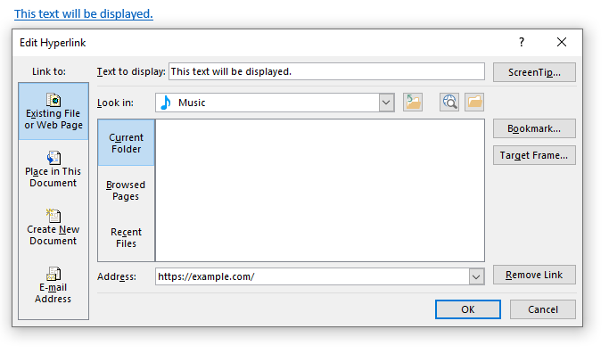

In order to edit the hyperlink, right-click on it and select the “Edit Hyperlink…” button.

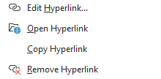

## Links to other uploaded files

:::{card} TODO 🚧  
Feature to be added in TNB-30: “As a reader I want to jump from a section to another section in the book”  
:::

## Cross-references

To enable a navigation between parts of your literary work, you have to **cross-reference** them. For tables, figures and equations, you have to insert a caption manually before you can cross-reference them. Without having to insert a caption, you can cross-reference:

* numbered items,
* headings.

Please note that at this moment we do not support bookmarks, footnotes and endnotes.

:::{important}  
For tables, figures and equations, you have to insert a caption manually before you can cross-reference them.  
:::

### Inserting captions

MS Word supports adding captions to tables, figures, equations.

To add a caption, simply open the “References” tab and select the “Insert Caption” button at the top of your MS Word window.

Figure . How to insert a caption.



A “Caption” window should appear. Select the “Label” to choose which type of resource are you referencing. For advanced settings of caption numbering, click the “Numbering…” button.

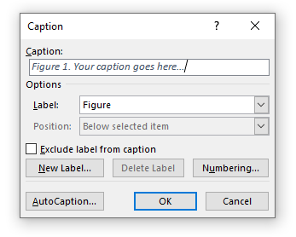

Note that each caption autoincrements automatically. To update a caption manually, right-click on the numbering item (e.g. on “1” in “Table 1. Some title”) and select “Update field”.

Examples of captions can be found below.

Table . A sample title

|  |  |
| --- | --- |
| Header 1 | Header 2 |
| Row 1, Column 1 | Row 1, Column 2 |
| Row 2, Column 1 | Row 2, Column 2 |

Figure . Example caption.



Equation .. An equation

:::{math}

d=D\sin \theta

:::

### Cross-referencing objects

To cross-reference an object within the Word file, go to the “References” tab at the top of the MS Word tab and click the “Cross-reference” button.

Figure . How to insert a cross-reference.



Chose the type of reference (e.g. header, footnote, table, figure, etc.) and select which caption you want to reference to. We recommend that you always insert a hyperlink in your cross-references.

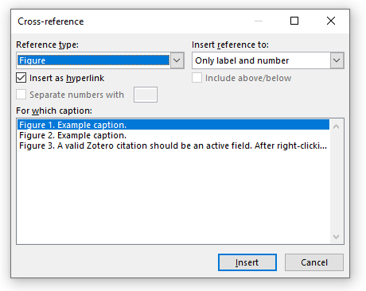

The “Insert reference to:” button allows you to set how the reference will appear in your work (e.g. “heading number” vs “heading text”). With tables, figures and equations you can insert reference to:

* Entire caption, e.g. Figure 2. Example caption.
* Only label and number, e.g. Figure 2
* Only caption text, e.g. Example caption.
* Above/below, e.g. above

Please do not reference page numbers, as this number is likely to change when transforming your book from MS Word to the printed and the digital version.

Without a need to insert a caption before, you can cross-reference:

numbered items (▷ Go to First item.),

headings (▷ ).

In such cases, just click on the “Cross-reference” button, choose the reference type and select the object to reference to. See the “*Figure 3. How to insert a cross-reference.*” on how to do it.

:::{tip}  
Cross-referencing headers can be particularly useful in referencing other parts of your literary work.  
:::

:::{tip}  
By inserting a captions to your figures, tables and equation you will not have to be concern with incrementing the numbering. MS Word will auto-increment captions for you.  
:::

### Generate table of figures

Another benefit from using the cross-references is that you can automatically generate the table of figures or other objects. To do that, navigate to the “References” tab in the top of the MS Word bar and click the “Insert Table of Figures” button.

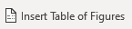

A window should appear where you can select options for your table of figures. We recommend however to always disable showing page numbers. You should also always use hyperlinks instead of page numbers.

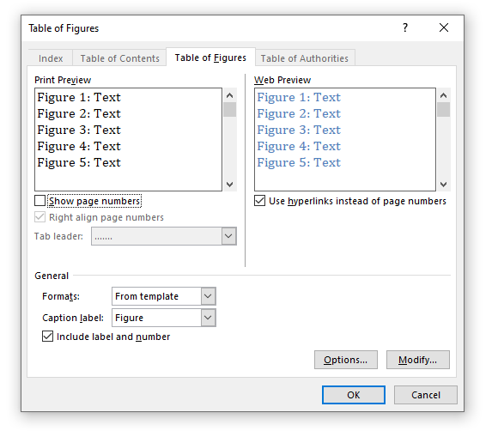

Please see below the exemplary table of figures used in this guidelines. Worth noting that only figures that have captions can be referenced, which means that only those figures can be referenced by a table of figures.

#### Exemplary table of figures used in the author guidelines

Figure 1. How to select a MS Word style.

Figure 2. How to get a link to embed a video from youtube.com.

Figure 3. How to insert a caption.

Figure 4. Example caption.

Figure 5. How to insert a cross-reference.

Figure 6. A valid Zotero citation should be an active field. After right-clicking it you should see options like 'Toggle Field Codes' (this option will allow you to see the internal data of your citation).

:::{important}  
Remember to update the table of figures after finishing writing and adding new items. The software will not update your table of figures for you.  
To update, you can **right-click on the table and select “Update field”**.  
:::

## 

## Citations

### Zotero

At current version of the platform, the only way to cite your sources is by using the Zotero with the Zotero Word Plugin. Zotero allows researchers to save references from library catalogs, research databases and other websites with a single click (Puckett 2017). Using Zotero, you can simply add, update and manage all citations in your work. A Zotero citation can look like that:

:::{card} An example of a citation  
A claim (see Fickers and Tatarinov 2022, vol. 2, chap. 1 for more examples).  
:::

Note that with Zotero, you manage the contents of the source centrally within your Zotero application. In your book or other literary work, you can add a reference to that source and optionally you can also add a prefix or a suffix or a page/chapter/figure/etc. you want to cite. Thus, the Zotero is the only source of truth regarding the quoted source and your current work is the only source of truth regarding the individual reference to the source.

:::{tip}  
In case of any questions about their usage, please refer to the [Zotero Word Plugin documentation](https://www.zotero.org/support/word_processor_plugin_usage).  
:::

#### Installation of Zotero

To install Zotero, please follow the instructions from the [official Zotero documentation](https://www.zotero.org/support/installation).

#### Installation of Zotero Word Plugin

Make sure that you have the Zotero Word Plugin installed by following the instructions in the [documentation](https://www.zotero.org/support/word_processor_plugin_installation). If you were able to install the plugin successfully, you should be able to see the Zotero tab in your MS Word program.

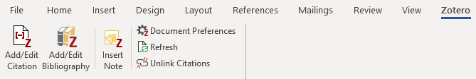

#### How to add/edit a citation

Please follow the [Zotero plugin instructions](https://www.zotero.org/support/word_processor_plugin_usage) on how to add and/or edit your citations.

You can begin citing with Zotero by clicking the “Add/Edit Citation” button. Pressing the button brings up the citation dialog. The citation dialog is used to select items from your Zotero library, and create a citation. Start typing part of a title, the last names of one or more authors, and/or a year in the dialog box. Matching items will instantly appear below the dialog box.

#### How to check if your citation is valid

A valid citation should be an active field, which can be updated, edited and to which you can toggle field codes to see their internals (see figure Figure 3). Do not use those options for editing – for that purpose use the “Add/Edit Citation” button on the top left corner of the MS Word “Zotero” tab. Please do not, under any circumstances, unlink your Zotero citations as this will irreversibly break them.

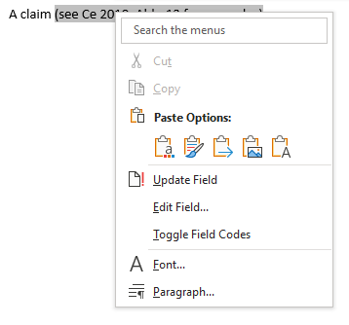

Figure . A valid Zotero citation should be an active field. After right-clicking it you should see options like 'Toggle Field Codes' (this option will allow you to see the internal data of your citation).

#### Document Preferences

You can always change options of your citations by setting the Document Preferences. In particular, you can change the citation style, language, whether the citations are displayed as footnotes or endnotes, etc.

:::{important}  
In the “Store Citations as” document preferences, we recommend to use the Fields option. Storing your citations as bookmarks may not render correct result.  
:::

By default, your citation will be rendered how you, the author, added it. Please note however that your document preferences might be overwritten by the platform. For example, a different citation style may be chosen by the publisher.

#### Bibliography

Please do not add a bibliography. The bibliography will be automatically generated for you. Creating a bibliography on your own will duplicate already existing bibliography.

:::{card} Note to self (dev note)  
When adding an asset metadata, maybe start with the licensing info of this one:  
(1) <https://www.pexels.com/photo/medium-short-coated-white-dog-on-white-textile-2607544/>  
(2) <https://www.pexels.com/photo/funny-dog-sitting-in-snow-at-a-forest-edge-19296608/>  
:::

1. Every main part of a book should open with “Heading 1”. There shouldn’t be more than one Heading 1 per docx file.
2. To insert a footnote in MS Word, you may click the “Insert Footnote” button or use the “Alt + Ctrl + F” key combination.
3. An example of endnotes.